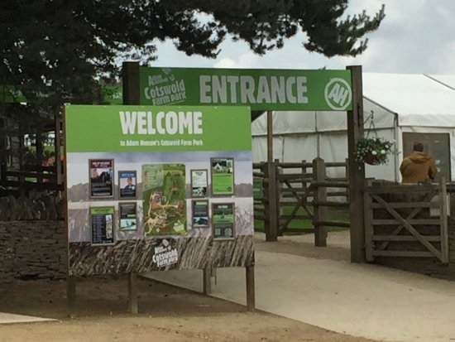

About Costworld Wildlife Zoo Park

What is Costworld Wildlife Park Zoo? and where is located established? Cotswold Wildlife Park, located near Burford in Oxfordshire, England, spans 160 acres of parkland and gardens surrounding a Victorian manor house. Established in 1970 by John Heyworth, the park remains under the ownership of the Heyworth family.

Opening & Closed Timings

Open daily from 10:00 AM to 6:00 PM

last admission at 4:00 PM.

the park is closed on Christmas Day. Additionally, from January 7th to February 6th, 2025.

the park will be closed on weekdays for essential maintenance but will remain open on weekends from 10:00 AM to 4:00 PM.

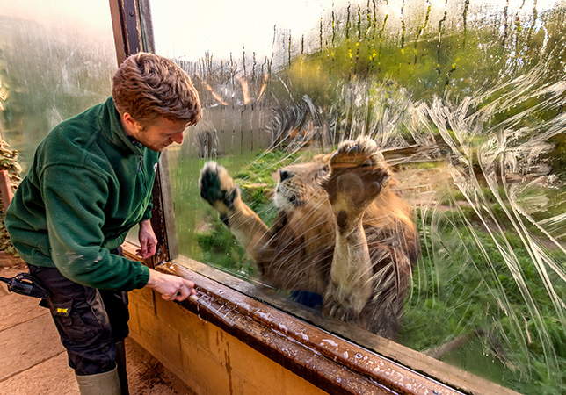

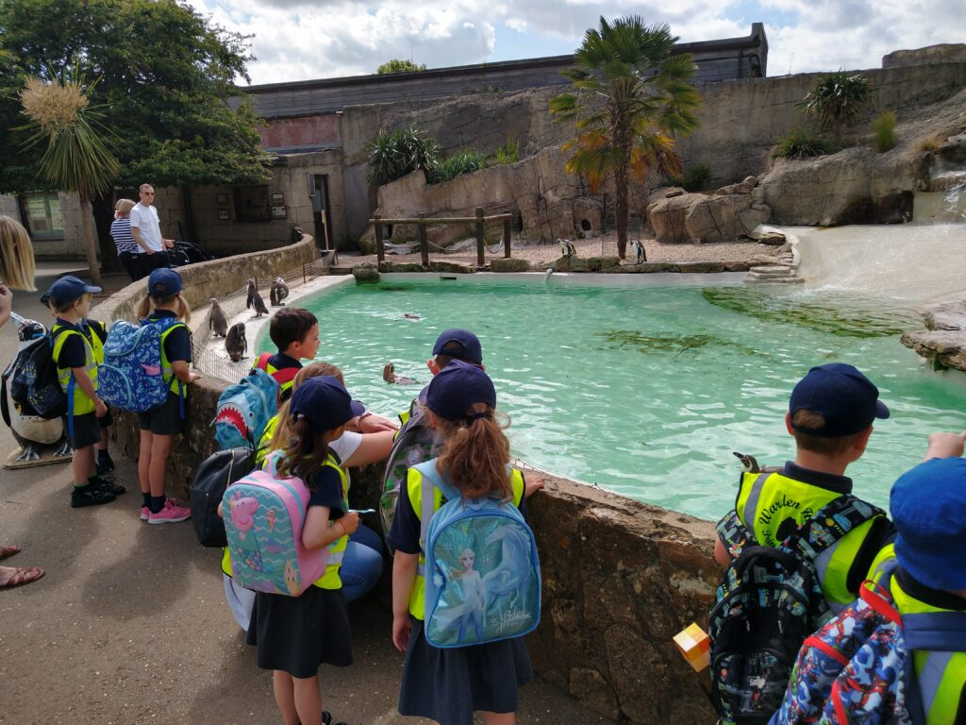

Animals List

The Cotswold Wildlife Park & Gardens exhibits over 260 different species of animals. The park is set in 160 acres of landscaped parkland and gardens 2 miles south of Burford, on the A361, Oxfordshire, England.

Around 350,000 people visited the park in 2012. Wikipedia

Chapman's Zebra

Giraffe

Wolverine

Clouded Leopard

Red Panda

Southern White Rhinoceros

Green Anaconda

Radiated Tortoise

Address & Contact

Address: Bradwell Grove, Burford OX18 4JP, United Kingdom.

Email: For specific enquiries, you can fill out the contact form available on their <br> enquiries@cotswoldwildlifepark.co.uk.

Phone: For urgent enquiries, you can call their Supporter Contact team at +44 1993 823006

For the most accurate and up-to-date information, it's recommended to visit the cotswoldwildlifepark.co.uk.